Deep learning output analysis
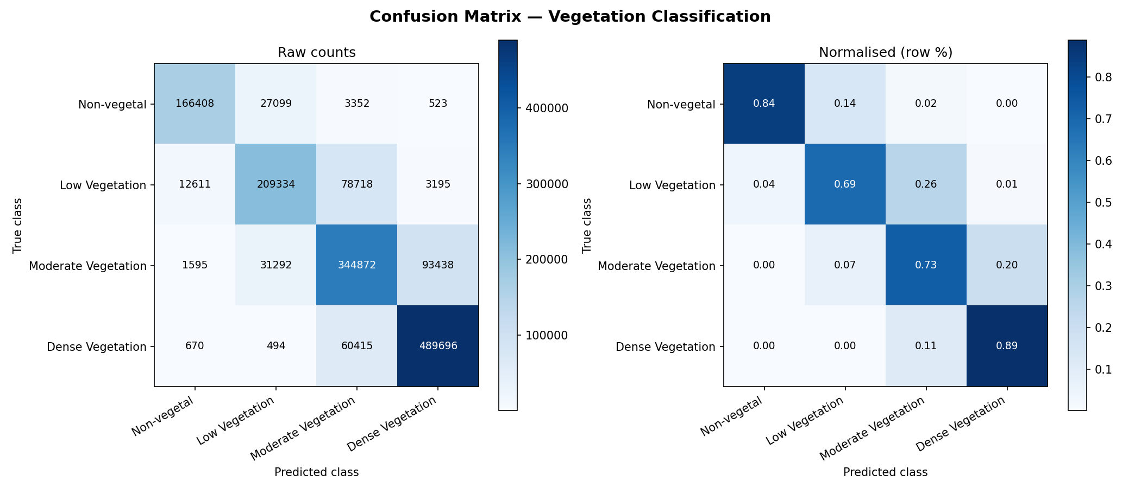
Figure 1. Confusion matrix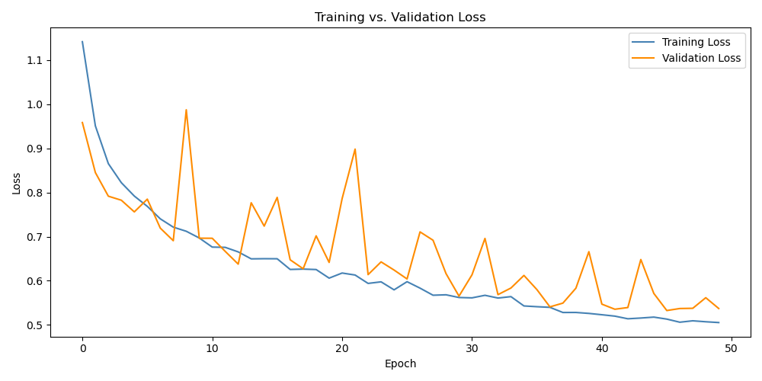
Figure 2. Loss curve
Process:
Strat by doing data augmentation to create more data for the model for better performance. Then, create a U-net encoder-decoder model to process the images. All code is divided by classes to make the main function easy to understand and readable.
Results:
Accuracy: 0.7943 (79.43%)
Precision: 0.8101 (macro avg)
Recall: 0.7880 (macro avg)
F1-Score: 0.7977 (macro avg)
Time: 41 minutes 34 seconds
Table 1. Classification Report
 | Precision | Recall | F1-score | Support
Non-vegetal | 0.92 | 0.84 | 0.88 | 197382
Low vegetal | 0.78 | 0.69 | 0.73 | 303858
Mederate Vegetation | 0.71 | 0.73 | 0.72 | 471197
Dense Vegetation | 0.83 | 0.89 | 0.86 | 551275
Accuracy | 0.79 |  |  | 1523712
Macro Avg | 0.81 |  |  | 1523712
Weighted avg | 0.80 |  |  | 1523712

SVM output analysis
Table 2. Classification Report
 | Precision | Recall | F1-score | Support
0 | 0.637658 | 0.704819 | 0.669559 | 5146.0000
1 | 0.568380 | 0.558576 | 0.563435 | 7247.0000
2 | 0.662067 | 0.723707 | 0.691516 | 14253.0000
3 | 0.922027 | 0.853173 | 0.886265 | 23354.0000
Accuracy | 0.758300 | 0.758300 | 0.758300 | 0.7583
Macro Avg | 0.697533 | 0.710069 | 0.702694 | 50000.0000
Weighted avg | 0.767398 | 0.758300 | 0.761655 | 50000.0000

Confusion Matrix
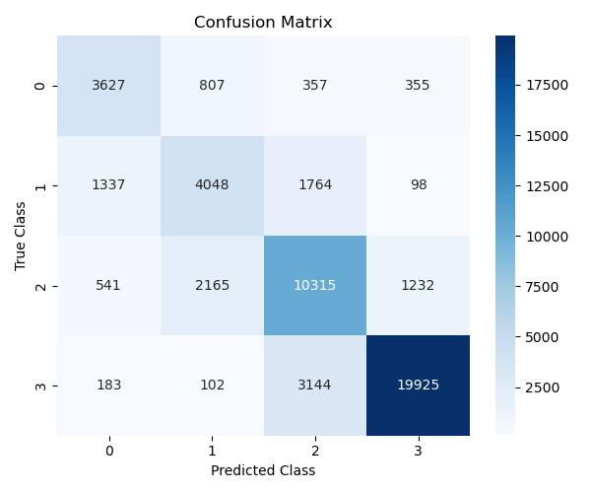
Figure 3. Confusion matrix
Process:
Create a dataset object that manage all the dataset preparation. We manage the features, which there will be the RGB and NDVI values of the images. Then we create a model object to manage everything about the model. We use Radial Base Function Kernel which make our model non-linear and a regularization of 1.0 (default). Then using matplotlib, create the confusion matrix.
Results:
The model and data management were simple so we couldn’t expect too much, with end up with an accuracy of 75.83%. This can be of course upgrade if we fine-tune the regularization, and better process of data. For time and resources management, we subsample the data to make it run faster and use less computational resources, choosing the data at random.
Comparison
The data management for each model was equal; there were no difference. However, we implement data augmentation for the deep learning model which we can see it in the results, getting a better accuracy with deep learning. Considering that we did not fine tune anything, both models have similar performance, however, the deep learning model takes more computational power.

